## How to start the mysql server





Run this to start the mysql server In local machine

### Another way to start server

Goto Windows+r 🡪 search for services🡪

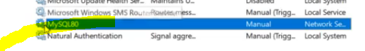

Right click and click start

To run the queries 🡪 launch mysql Workbench

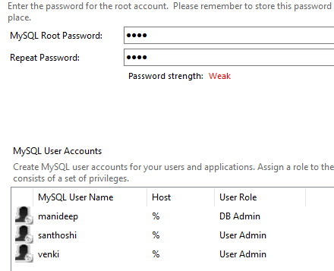

my my sql password

root

root

manideep

MANIdeep123

santhoshi

SANtu123

venki

venki